**DIGITAL SECUTIY FOR USB MOBILE**

**APPLICATION**

1 K.Dinesh, 2M.Sarath Kumar ,3Mr.T.Gopinath

B.E, Department of Computer Science and Engineering, Chettinad College of Engineering and Technology,

Karur.

1 dinesh14cs007@gmail.com

2 sharathb2427@gmail.com

3

Assistant Professor, Department of Computer Science, Chettinad College Of Engineering and Technology,

Karur.

**ABSTRACT**

The Digital Security mobile application used for a secure data. While connecting USB cable in our mobile easily accessing the data so the digital security application will be protect the storage data (gallery, files,documents,etc)Data security means protecting digital data, such as those in a database, from destructive forces and from the unwanted actions of unauthorized users such as unlock the mobile.

All the information about user maintained in the Mobile storage. Some unauthorized users easily open and accessing user data we can identify the unauthorized users based upon security methods.

**Keywords:** Android, Attendance and Mark Management, Authentication, smart phone.

**1. INTRODUCTION**

We present an android-based approach for the design of mobile security purpose. There are large amount of applications for handheld devices are available in the market. Software industries traditionally generated vast amount of mobile applications for the customers.to develop an android application which is used to hide the files in an android phone and it cannot be visible when it connected to the computer via usb.

It will used to secretly hide the files from other person. The android file hiding application is used to hide the files in the internal storage and SD card in the mobile phones.

The application modules are pin lock, files hiding. In the setting pin lock to protect file from other in the mobile phone. Then another module in the file hiding vault to hide the files. Any files can be hiding in the SD card and internal system.

**2. ANDROID ARCHITECTURE**

We studied the Android system architecture. Android system is a Linux-based system, Use of the framework and Applications [5-8].Each layer of the lower encapsulation, while providing call interface to the upper.

Software stack architecture design patterns [1-2].As shown in Figure 1, the Android architecture consists of four layers: Linux kernel, Libraries and Android runtime, Application

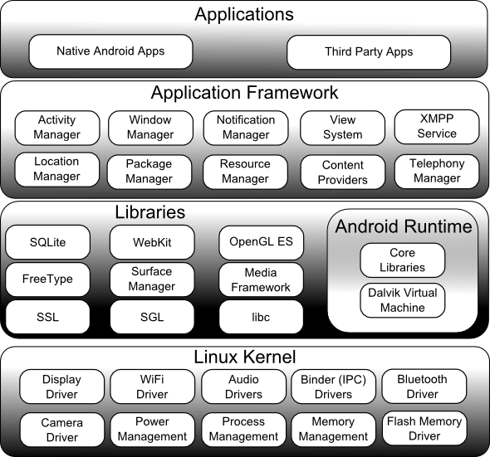

**2.1. Applications**

Android app will be shipped with a set of core applications including client, SMSProgram, calendar, maps, browser, contacts, and others. All these application programs are developed in java.

**2.2. Application Framework**

The developer is allowed to access all the API framework of the core programs. The Application framework simplifies the reuse of its components. Any other app can release its functional components and all other apps can access and use this component (but have to follow the security of the framework). Same as the users can be able to substitute the program components with this reuse mechanism.

**2.3. LIBRARIES AND ANDROID RUNTIME**

The library is divided into two components: Android Runtime and Android Library. Android Runtime is consisted of a Java Core Library and Dalvik virtual machine. The Core Library provides Java core library with most functions. Dalvik virtual machine is register virtual machine and makes some specific improvements for mobile device.

Android system library is support the application framework; it is also an important link connecting between application framework and Linux Kernel. This system library is developed in C or C++ language. These libraries can also be utilized by the different components in the Android system. They provide service for the developers through the application framework.

**3.1 Problem Statement**

As there are various chances of misplacing the phone or losing it is not affordable in day today’s scenario. We present an android-based approach for the design of Digital Security Application for the smart-phone. The purpose behind developing this project is to provide the user to secure the data connecting USB cable to device.

**EXISITING SYSTEM**

In the existing system only locking the internal storage. They easily connecting the USB cable and accessing the data. But we are overcome the problem in that application.

**System Architecture**

File hided from the file manager

Hide the files

Install the application

**PROPOSED SYSTEM**

Initial step is installing the application and after installation process then register user Detail for one time registration. In that registration page contains user name, password and mail id.After completing registration process then move to menu page that contains locking options (pin, pattern, password) then select one option move to the next page. For example first set pattern after completing the set pattern then set the confirm pattern.

All information maintained by the admin.Then select the folders on the storage and locks the data. Digital Security can be provided to the status viewer. Digital security protects not only your phone but also your privacy and all the necessary features to keep your phone safe & healthy.

Keep your phone and privacy safe from unauthorized users. In future we are adding Intruder Selfie - Take photo of intruders who trying to break in your phone. Application feature protects apps privacy from snoopers. (Intruder Selfie for phone lock screen needs device administrator permission).

**SCOPE**

1. Users data should be security and high level protection.

2.Simple to use.

3. Cost Efficient.

4. Hide the data and easy protection.

5. Easily encrypt the files.

6. Data occupies storage is very less space.

**LOCK FILES**

Enter the pin and move to the lock files option then they show your internal storage system and select files such (video, audio, document, etc.) and after selecting the files then press the lock button. Now files are lock at encryption method to files should be hiding on the mobile phone. Then connecting USB cable to system they didn’t show their files.

**UNLOCK FILES**

After locking the files, need to unlock that file press unlocking the files then that files should be decrypted on the locking folder to unlocking folder so there was a decrypting operation on the data files.

Finally got the old original file.

After Encryption the file size should be reduced comparing to original file.

**ENCRYPTION**

The Data Encryption Standard is a symmetric-key algorithm for the encryption of electronic data. Although now considered insecure, it was highly influential in the advancement of modern cryptography

**DECRYPTION**

Decryption is the process of taking encoded or encrypted text or other data and converting it back into text that you or the computer can read and understand. This term could be used to describe a method of un-encrypting the data manually or with un-encrypting the data using the proper codes or keys.

**PROJECT REQUIREMENTS:**

**SYSTEM REQUIREMENTS**

Selection of software and language

Front end: Java

Back end: PHP MySQL

Platform: Windows 7 and higher versions

IDE: Android Studio 3.0.1

Selection of hardware

Processor: Intel i5 core

Hard disk: 80 GB

RAM: 8 GB

Other hardware: Android Mobile with Android Apps.

**CONCLUSION**

This is An Android Application to secure data and Providing Security Mobile phones this is an unique efficient application which has a variety of features that enhances the Current mobile Security system as we are using a totally new technology of hiding data while connecting USB Cable to the Security Mobile Phone.

**REFRENCES**

[1][https://www.simplifiedcodind.net/android-json-parsing-retrive-from-mysql-database](https://www.simplifiedcodind.net/android-%20%20%20%20%20%20%20%20%20%20json-parsing-retrive-from-mysql-database)

[2] <https://www.geks.gallery/retrive-data-from-mysql-database-using-php-and-displaying-it-by-tableview-in-android/>

[3] [https://www.tutorialspoint.com/ android/](https://www.tutorialspoint.com/%20android/)

[4] The Busy Coder's Guide to Android Development, Jul 2008: Version 1.0, ISBN: 978-0-9816780-0-9.

[5]https://www.youtube.com/watch?v=I7Fq020FaAw

[6]https://www.youtube.com/watch?v=e8x-nu9-_BM

[7] https://android-studio.en.uptodown.com/mac

[8]https://code.tutsplus.com/tutorials/code-an-image-gallery-android-app-with-glide--cms-28207

[9]https://www.journaldev.com/9546/android-gallery-view-example-tutorial

[10] http://blog.iamsuleiman.com/image-gallery-app-android-studio-1-4-glide/

[11]https://www.codeproject.com/Articles/1193818/Image-Gallery-App-in-Android

[12]https://medium.com/@janishar.ali/android-advance-image-gallery-example-3ec6ddf85ed9

[13]https://www.androidhive.info/2016/04/android-glide-image-library-building-image-gallery-app/

[14]https://stackoverflow.com/questions/32870673/android-studio-upload-video-to-serve